Section II – Market Assessment

Ballard*King & Associates (B*K) has been contracted by OLC to complete a market assessment for Johnstown, Colorado for an outdoor aquatic center. The first step to complete this scope of work is to determine service areas for analysis and recreation/leisure activities.

The following is a summary of the demographic characteristics within areas identified as the Primary and Secondary Service Areas. The Primary Service Area encompasses the Town of Johnstown, CO. The Secondary Service Area is an approximate 15-minute drive time to the proposed site.

B*K accesses demographic information from Environmental Systems Research Institute (ESRI) who utilizes 2020 Census data and their demographers for 2022-2027 projections. In addition to demographics, ESRI also provides data on housing, recreation, and entertainment spending and adult participation in activities. B*K also uses information produced by the National Sporting Goods Association (NSGA) to overlay onto the demographic profile to determine potential participation in various activities.

Service Areas:
The information provided includes the basic demographics and data for the Primary and Secondary Service Area with comparison data for the State of Colorado and the United States.

Primary Service Areas are defined as the distance people will travel on a regular basis (a minimum of once a week) to utilize recreation facilities. Use by individuals outside of this area will be much more limited and will focus more on special activities or events.

Service areas can flex or contract based upon a facility’s proximity to major thoroughfares. Other factors impacting the use as it relates to driving distance are the presence of alternative service providers in the service area. Alternative service providers can influence participation, membership, daily admissions and the associated penetration rates for programs and services.

Service areas can vary in size with the types of components in the facility.

Service Area Maps

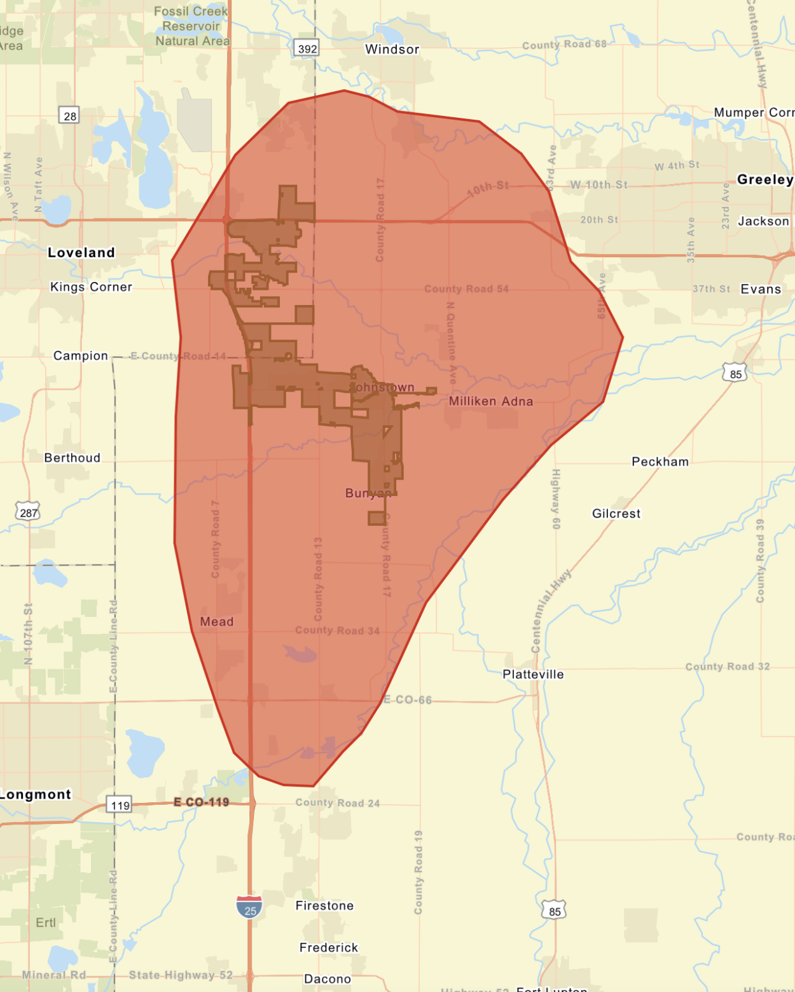
- Green Boundary – Primary Service Area (Johnstown)
- Red Boundary – Secondary Service Area (15-minute drive time)
Infographic
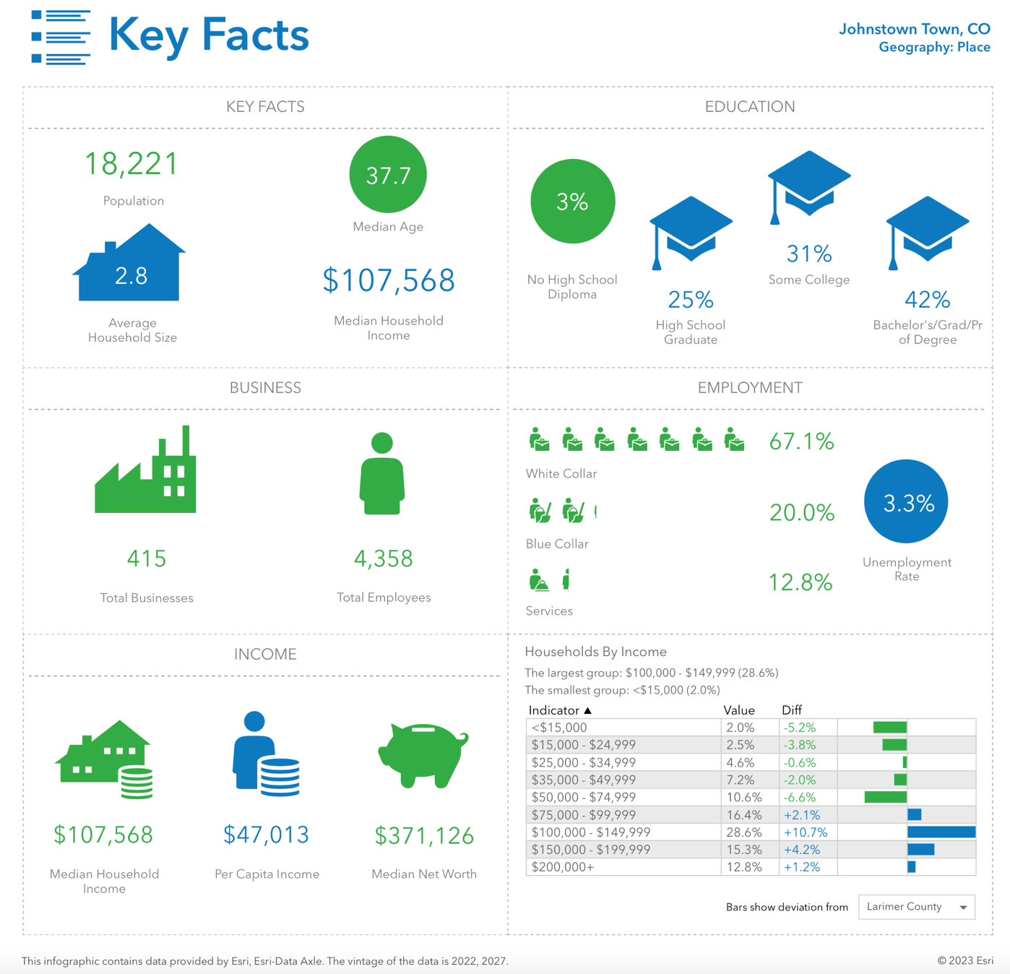
- Households by Income comparison uses the Primary Service Area and compares it to Larimer County.

Demographic Summary

 | Primary  Service Area | Secondary  Service Area
Population:
2020 Census | 17,303 | 48,021
2022 Estimate | 18,221 | 54,732
2027 Estimate | 20,380 | 60,305
Households:
2020 Census | 6,185 | 16,760
2022 Estimate | 6,573 | 19,178
2027 Estimate | 7,310 | 21,107
Families:
2020 Census | 4,491 | 12,613
2022 Estimate | 5,186 | 15,191
2027 Estimate | 5,756 | 17,581
Average Household Size:
2020 Census | 2.80 | 2.86
2022 Estimate | 2.77 | 2.85
2027 Estimate | 2.79 | 2.85
Ethnicity
(2022 Estimate):
Hispanic | 16.5% | 17.9%
White | 81.2% | 80.3%
Black | 0.7% | 0.7%
American Indian | 0.9% | 0.8%
Asian | 1.6% | 1.4%
Pacific Islander | 0.1% | 0.1%
Other | 5.2% | 5.8%
Multiple | 10.4% | 11.0%
Median Age:
2020 Census | 34.6 | 34.8
2022 Estimate | 37.7 | 37.1
2027 Estimate | 37.6 | 36.8
Median Income:
2022 Estimate | $107,568 | $106,991
2027 Estimate | $118,576 | $118,007

Age and Income: The median age and household income levels are compared with the national number as both of these factors are secondary determiners of participation in recreation activities. The lower the median age, the higher the participation rates are for most activities. The level of participation also increases as the median income level goes up.

Table A – Median Age:

 | 2020 Census | 2022 Projection | 2027 Projection
Primary Service Area | 34.6 | 37.7 | 37.6
Secondary Service Area | 34.8 | 37.1 | 36.8
State of Colorado | 36.1 | 37.9 | 38.3
Nationally | 38.6 | 38.9 | 39.6

Chart A – Median Age:

The median age in the Primary Service Area is marginally lower than the State of Colorado and the National number. A lower median age typically points to the presence of families with children. Parks and recreation activities, programs and events draw a large demographic but tend to be most popular with youth and their parents. Grandparents are becoming an increasing part of the household though, as they care for and are involved with their grandchildren.

The following chart provides the number of households and percentage of households in the Primary and Secondary Service Area with children.

Table B – Households w/ Children

 | Number of Households w/ Children | Percentage of Households w/ Children
Primary Service Area | 2,329 | 37.5%
Secondary Service Area | 6,504 | 39.3%
State of Colorado | -- | 29.9%

The information contained in Table-B helps further outline the presence of families with children. As a point of comparison in the 2020 Census, 30.7% of households nationally had children present.

Map B – Median Age by Census Tracts

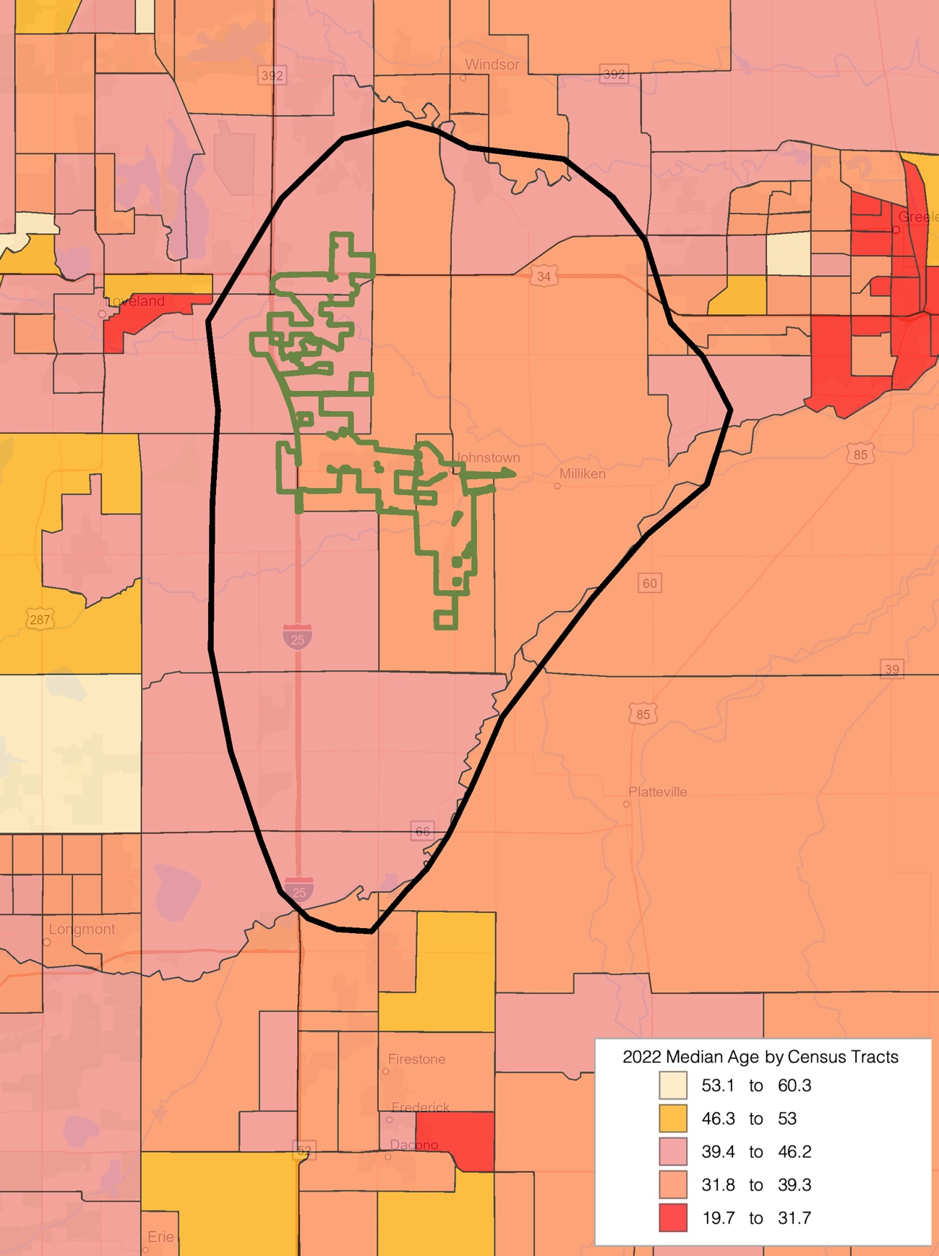

Table C – Median Household Income:

 | 2022 Projection | 2027 Projection
Primary Service Area | $107,568 | $118,576
Secondary Service Area | $106,991 | $118,007
State of Colorado | $84,521 | $101,706
Nationally | $72,414 | $84,445

Chart B – Median Household Income:

Based on 2022 projections for median household income the following narrative describes the service areas:

In the Primary Service Area, the percentage of households with median income over $50,000 per year is 83.8% compared to 61.6% on a national level. Furthermore, the percentage of the households in the service area with median income less than $25,000 per year is 4.5% compared to a level of 18.0% nationally.

In the Secondary Service Area, the percentage of households with median income over $50,000 per year is 85.2% compared to 61.6% on a national level. Furthermore, the percentage of the households in the service area with median income less than $25,000 per year is 5.2% compared to a level of 18.0% nationally.

While there is no perfect indicator of use of an aquatic facility, the percentage of households with more than $50,000 median income is a key indicator. Therefore, those numbers are significant and balanced with the overall cost of living.

Chart C – Median Household Income Distribution

Map C – Household Income by Census Tracts

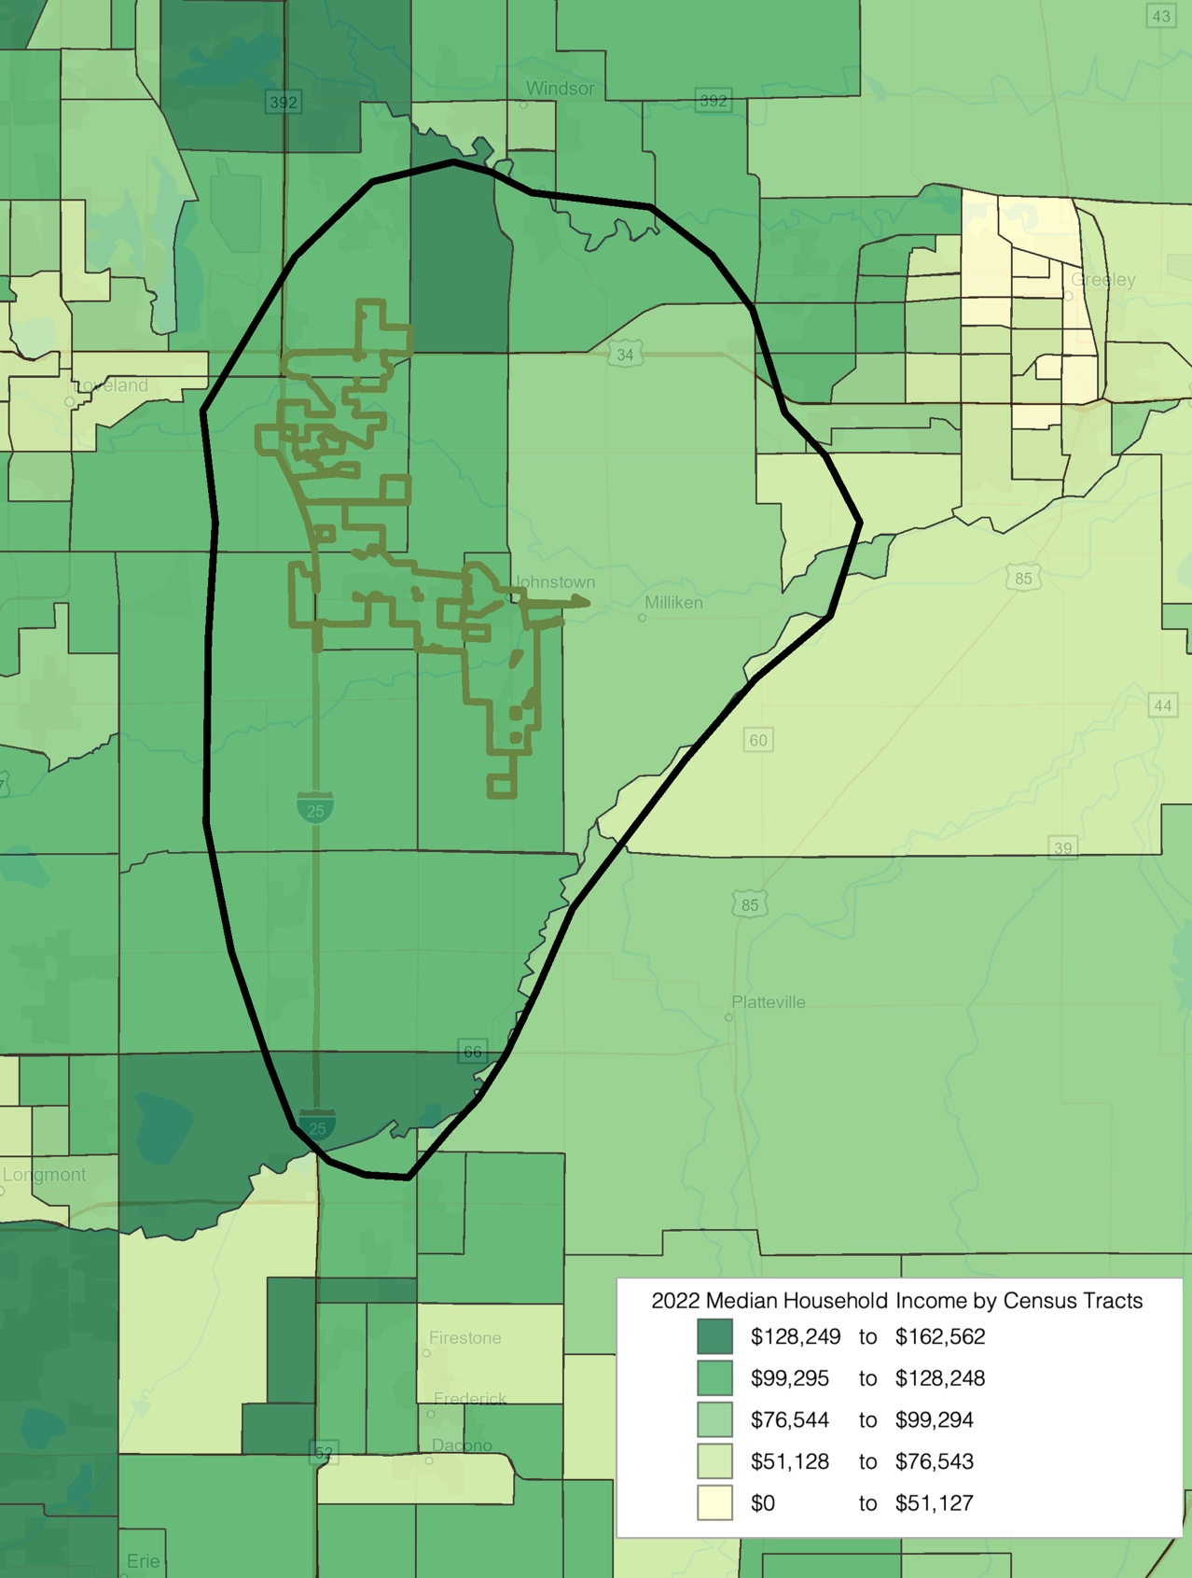

In addition to taking a look at the Median Age and Median Income, it is important to examine Household Budget Expenditures. In particular, reviewing housing information; shelter, utilities, fuel and public services along with entertainment & recreation can provide a snapshot into the cost of living and spending patterns in the services areas. The table below looks at that information and compares the service areas.

Table D – Household Budget Expenditures:

Primary Service Area | SPI | Average Amount Spent | Percent
Housing | 125 | $35,786.85 | 31.3%
Shelter | 125 | $28,697.97 | 25.1%
Utilities, Fuel, Public Service | 125 | $7,088.87 | 6.2%
Entertainment & Recreation | 128 | $4,702.94 | 4.1%

Secondary Service Area | SPI | Average Amount Spent | Percent
Housing | 127 | $36,392.53 | 31.6%
Shelter | 128 | $29,393.52 | 25.5%
Utilities, Fuel, Public Service | 124 | $6,999.01 | 6.1%
Entertainment & Recreation | 128 | $4,689.27 | 4.1%

State of Colorado | SPI | Average Amount Spent | Percent
Housing | 113 | $32,316.90 | 31.9%
Shelter | 114 | $26,016.47 | 25.7%
Utilities, Fuel, Public Service | 111 | $6,300.43 | 6.2%
Entertainment & Recreation | 112 | $4,113.53 | 4.1%

SPI: Spending Potential Index as compared to the National number of 100.
Average Amount Spent: The average amount spent per household.
Percent: Percent of the total 100% of household expenditures.

Note: Shelter along with Utilities, Fuel, Public Service are a portion of the Housing percentage.

Chart D – Household Budget Expenditures Spending Potential Index:

The consistency between the median household income and the household budget expenditures is important. It also points to the fact that compared to a National level the dollars available, the money being spent in the Primary Service Area is significantly higher. This could point to the ability to pay for programs and services offered at a recreation facility of any variety.

The total number of housing units in the Primary Service Area is 6,434 and 96.1% are occupied, or 6,185 housing units. The total vacancy rate for the service area is 0%. As a comparison, the vacancy rate nationally was 11.6%. Of the available units:
- For Rent 0.4%
- Rented, not Occupied 0.0%
- For Sale 0.0%
- Sold, not Occupied 0.0%
- For Seasonal Use 0.0%
- Other Vacant 0.0%

The total number of housing units in the Secondary Service Area is 18,074 and 92.7% are occupied, or 16,760 housing units. The total vacancy rate for the service area is 2%. As a comparison, the vacancy rate nationally was 11.6%. Of the available units:
- For Rent 1.1%
- Rented, not Occupied 0.0%
- For Sale 0.0%
- Sold, not Occupied 0.1%
- For Seasonal Use 0.1%
- Other Vacant 0.3%
Recreation Expenditures Spending Potential Index: Finally, through the demographic provider that B*K utilizes for the market analysis portion of the report, we can examine the overall propensity for households to spend dollars on recreation activities. The following comparisons are possible.

Table E – Recreation Expenditures Spending Potential Index:

Primary Service Area | SPI | Average Spent
Fees for Participant Sports | 141 | $184.61
Fees for Recreational Lessons | 138 | $220.75
Social, Recreation, Club Membership | 131 | $369.87
Exercise Equipment/Game Tables | 142 | $88.86
Other Sports Equipment | 140 | $11.30

Secondary Service Area | SPI | Average Spent
Fees for Participant Sports | 145 | $190.20
Fees for Recreational Lessons | 146 | $233.77
Social, Recreation, Club Membership | 134 | $378.75
Exercise Equipment/Game Tables | 145 | $91.01
Other Sports Equipment | 144 | $11.64

State of Colorado | SPI | Average Spent
Fees for Participant Sports | 116 | $151.59
Fees for Recreational Lessons | 114 | $181.96
Social, Recreation, Club Membership | 114 | $322.49
Exercise Equipment/Game Tables | 117 | $73.39
Other Sports Equipment | 116 | $9.35

Average Amount Spent: The average amount spent for the service or item in a year.
SPI: Spending potential index as compared to the national number of 100.

Chart E – Recreation Spending Potential Index:

Again, there is a great deal of consistency between median household income, household budget expenditures and now recreation and spending potential.
Map D – Recreation Spending Potential Index by Census Tract

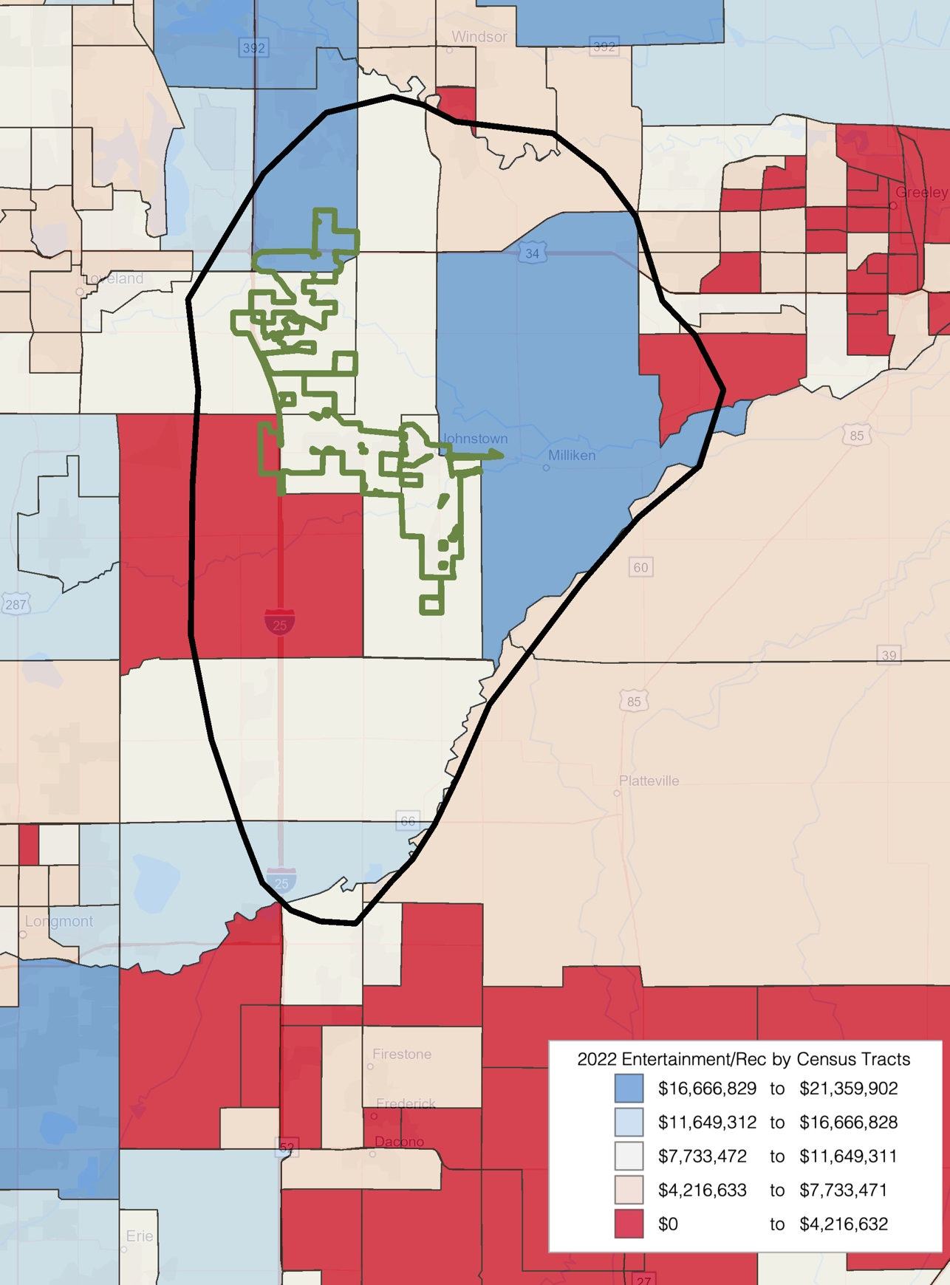

Population Distribution by Age: Utilizing census information for the Primary and Secondary Service Areas, the following comparisons are possible.

Table F – 2022 Primary Service Area Age Distribution
(ESRI estimates)

Ages | Population | % of Total | Nat. Population | Difference
0-5 | 1,321 | 7.3% | 5.8% | +1.5%
5-17 | 3,452 | 19.0% | 15.9% | +3.1%
18-24 | 1,182 | 6.5% | 9.2% | -2.7%
25-44 | 5,137 | 28.2% | 26.8% | +1.4%
45-54 | 2,216 | 12.2% | 12.0% | +0.2%
55-64 | 2,253 | 12.4% | 12.8% | -0.4%
65-74 | 1,790 | 9.8% | 10.2% | -0.4%
75+ | 870 | 4.8% | 7.2% | -2.4%

Population: 2022 census estimates in the different age groups in the Primary Service Area.
% of Total: Percentage of the Primary Service Area population in the age group.
National Population: Percentage of the national population in the age group.
Difference: Percentage difference between the Primary Service Area population and the national population.

Chart F – 2022 Primary Service Area Age Group Distribution

The demographic makeup of the Primary Service Area, when compared to the characteristics of the national population, indicates that there are some differences with a smaller population in the age groups 18-24, 55-64, 65-74 and 75+. The greatest positive variance is in the 5-17 age group with +3.1%, while the greatest negative variance is in the 18-24 age group with -2.7%.

Table G – 2022 Secondary Service Area Age Distribution
(ESRI estimates)

Ages | Population | % of Total | Nat. Population | Difference
0-5 | 4,009 | 7.3% | 5.8% | +1.5%
5-17 | 10,665 | 19.5% | 15.9% | +3.6%
18-24 | 3,911 | 7.2% | 9.2% | -2.1%
25-44 | 15,369 | 28.1% | 26.8% | +1.3%
45-54 | 6,765 | 12.4% | 12.0% | +0.4%
55-64 | 6,546 | 12.0% | 12.8% | -0.8%
65-74 | 4,967 | 9.1% | 10.2% | -1.1%
75+ | 2,499 | 4.6% | 7.2% | -2.6%

Population: 2022 census estimates in the different age groups in the Secondary Service Area.
% of Total: Percentage of the Secondary Service Area population in the age group.
National Population: Percentage of the national population in the age group.
Difference: Percentage difference between the Secondary Service Area population and the national population.

Chart G – 2022 Secondary Service Area Age Group Distribution

The demographic makeup of the Secondary Service Area, when compared to the characteristics of the national population, indicates that there are some differences with a larger population in the Under 5, 5-17, 25-44, and 45-54 age groups. A smaller population in the 18-24, 55-64 and 65-74 age groups. The greatest positive variance is in the 5-17 age group with +3.6%, while the greatest negative variance is in the 75+ age group with -2.6%.

Population Distribution Comparison by Age: Utilizing census information from the Primary and Secondary Service Area, the following comparisons are possible.

Table H – 2022 Primary Service Area Population Estimates
(U.S. Census Information and ESRI)

Ages | 2020 Census | 2022 Projection | 2027 Projection | Percent Change | Percent Change Nat’l
-5 | 1,584 | 1,321 | 1,508 | -4.8% | -8.3%
5-17 | 3,722 | 3,452 | 3,877 | +4.2% | -8.5%
18-24 | 976 | 1,182 | 1,275 | +30.6% | -8.9%
25-44 | 5,396 | 5,137 | 5,762 | +6.8% | +3.3%
45-54 | 2,218 | 2,216 | 2,465 | +11.1% | -17.8%
55-64 | 1,844 | 2,253 | 2,247 | +21.9% | +2.5%
65-74 | 1,112 | 1,790 | 2,063 | +85.5% | +58.2%
75+ | 466 | 870 | 1,186 | +154.5% | +46.3%

Chart H – Primary Service Area Population Growth

Table-H illustrates the growth or decline in age group numbers from the 2020 census until the year 2027. It is projected that all age categories except under 5 will see an increase in population. The population of the United States as a whole is aging, and it is not unusual to find negative growth numbers in the younger age groups and significant net gains in the 45 plus age groupings in communities which are relatively stable in their population numbers.

Table I – 2022 Secondary Service Area Population Estimates
(U.S. Census Information and ESRI)

Ages | 2020 Census | 2022 Projection | 2027 Projection | Percent Change | Percent Change Nat’l
-5 | 4,121 | 4,009 | 4,510 | +9.4% | -8.3%
5-17 | 10,364 | 10,665 | 11,654 | +12.4% | -8.5%
18-24 | 2,868 | 3,911 | 4,111 | +43.3% | -8.9%
25-44 | 14,224 | 15,369 | 17,288 | +21.5% | +3.3%
45-54 | 6,800 | 6,765 | 7,312 | +7.5% | -17.8%
55-64 | 5,455 | 6,546 | 6,335 | +16.1% | +2.5%
65-74 | 2,843 | 4,967 | 5,679 | +99.8% | +58.2%
75+ | 1,359 | 2,499 | 3,422 | +151.8% | +46.3%

Chart I – Secondary Service Area Population Growth

Table-I illustrates the growth or decline in age group numbers from the 2020 census until the year 2027. It is projected that all age categories will see an increase in population. The population of the United States as a whole is aging, and it is not unusual to find negative growth numbers in the younger age groups and significant net gains in the 45 plus age groupings in communities which are relatively stable in their population numbers.

Below is listed the distribution of the population by race and ethnicity for the Primary and Secondary Service Area for 2022 population projections. Those numbers were developed from 2020 Census Data.

Table J – Primary Service Area Ethnic Population and Median Age 2022
(Source – U.S. Census Bureau and ESRI)

Ethnicity | Total Population | Median Age | % of Population | % of CO Population
Hispanic | 2,999 | 27.3 | 16.5% | 22.0%

Table K – Primary Service Area by Race and Median Age 2022
(Source – U.S. Census Bureau and ESRI)

Race | Total Population | Median Age | % of Population | % of CO Population
White | 14,790 | 39.9 | 81.2% | 70.2%
Black | 126 | 32.5 | 0.7% | 4.1%
American Indian | 162 | 41.0 | 0.9% | 1.3%
Asian | 282 | 36.2 | 1.6% | 3.5%
Pacific Islander | 12 | 20.0 | 0.1% | 0.2%
Other | 950 | 30.2 | 5.2% | 8.1%
Multiple | 1,899 | 19.4 | 10.4% | 12.6%

2022 Primary Service Area Total Population: 18,221 Residents

Chart J – 2022 Primary Service Area Population by Non-White Race

Table L – Secondary Service Area Ethnic Population and Median Age 2022
(Source – U.S. Census Bureau and ESRI)

Ethnicity | Total Population | Median Age | % of Population | % of CO Population
Hispanic | 9,785 | 26.1 | 17.9% | 22.0%

Table M – Secondary Service Area by Race and Median Age 2022
(Source – U.S. Census Bureau and ESRI)

Race | Total Population | Median Age | % of Population | % of CO Population
White | 43,937 | 39.7 | 80.3% | 70.2%
Black | 376 | 29.6 | 0.7% | 4.1%
American Indian | 441 | 38.7 | 0.8% | 1.3%
Asian | 754 | 36.2 | 1.4% | 3.5%
Pacific Islander | 37 | 29.2 | 0.1% | 0.2%
Other | 3,160 | 28.5 | 5.8% | 8.1%
Multiple | 6,028 | 19.6 | 11.0% | 12.6%

2022 Secondary Service Area Total Population: 54,732 Residents

Chart K – 2022 Secondary Service Area Population by Non-White Race

Tapestry Segmentation

Tapestry segmentation represents the 4th generation of market segmentation systems that began 30 years ago. The 65-segment Tapestry Segmentation system classifies U.S. neighborhoods based on their socioeconomic and demographic compositions. While the demographic landscape of the U.S. has changed significantly since the 2000 Census, the tapestry segmentation has remained stable as neighborhoods have evolved.

There is value including this information for Johnstown, CA. The data assists the organization in understanding the consumers/constituents in their service area and supply them with the right products and services.

The Tapestry segmentation system classifies U.S. neighborhoods into 65 unique market segments. Neighborhoods are sorted by more than 60 attributes including; income, employment, home value, housing types, education, household composition, age and other key determinates of consumer behavior.

The following pages and tables outline the top 5 tapestry segments in each of the service areas and provide a brief description of each. This information combined with the key indicators and demographic analysis of each service area help further describe the markets that the Primary and Secondary Service Area looks to serve with programs, services, and special events.

For comparison purposes the following are the top 10 Tapestry segments, along with percentage in the United States:

- Green Acres (6A) 3.2%
- Southern Satellites (10A) 3.1%
- Savvy Suburbanites (1D) 3.0%
- Workday Drive (4A) 2.9%
- Middleburg (4C) 2.9%
15.1%

- Salt of the Earth (6B) 2.9%
- Up and Coming Families (7A) 2.5%
- Midlife Constants (5E) 2.5%
- Comfortable Empty Nesters (5A) 2.4%
- Old and Newcomers (8F) 2.3%
12.6%

Table N – Primary Service Area Tapestry Segment Comparison
(ESRI estimates)

 | Primary Service Area |  | Demographics
 | Percent | Cumulative Percent | Median Age | Median HH Income
Up and Coming Families (7A) | 30.9% | 30.9% | 31.4 | $72,000
Green Acres (6A) | 20.5% | 51.4% | 43.9 | $76,800
Urban Chic (2A) | 14.9% | 66.3% | 43.3 | $109,400
Middleburg (4C) | 12.2% | 78.5% | 36.1 | $59,800
Boomburbs (1C) | 11.0% | 89.5% | 34.0 | $113,400

Chart L – Primary Service Area Tapestry Segment Entertainment Spending:

Up and Coming Families (7A) – A young, diverse and mobile market. Hardworking families trying to get ahead, they seek technology. Careful shoppers fill spare time with family activities.

Green Acres (6A) – Lifestyle that features self-reliance. Enjoy maintaining home/yard, being outside and playing sports. Most households no longer have children. Conservative and cautious.

Urban Chic (2A) – Professionals living an exclusive lifestyle. Environmentally aware and like to live “green.” Embrace city life with museums, arts, culture and sports.

Middleburg (4C) – This group is conservative and family-oriented. A younger market that is growing. Prefers to buy American for a good price. Participate in sports and outdoor activities.

Boomburbs (1C) – A new growth market with many young professionals with families. Fitness is a priority, including club memberships. Enjoy all sports and generous supporters of the arts.

Table O – Secondary Service Area Tapestry Segment Comparison
(ESRI estimates)

 | Secondary Service Area |  | Demographics
 | Percent | Cumulative Percent | Median Age | Median HH Income
Up and Coming Families (7A) | 32.0% | 32.0% | 31.4 | $72,000
Urban Chic (2A) | 21.3% | 53.3% | 43.3 | $109,400
Boomburbs (1C) | 14.1% | 67.4% | 34.0 | $113,400
Green Acres (6A) | 11.3% | 78.7% | 43.9 | $76,800
Workday Drive (4A) | 5.3% | 84.0% | 37.0 | $90,500

Chart M – Secondary Service Area Tapestry Segment Entertainment Spending:

Up and Coming Families (7A) – A young, diverse and mobile market. Hardworking families trying to get ahead, they seek technology. Careful shoppers fill spare time with family activities.

Urban Chic (2A) – Professionals living an exclusive lifestyle. Environmentally aware and like to live “green.” Embrace city life with museums, arts, culture and sports.

Boomburbs (1C) – A new growth market with many young professionals with families. Fitness is a priority, including club memberships. Enjoy all sports and generous supporters of the arts.

Green Acres (6A) – Lifestyle that features self-reliance. Enjoy maintaining home/yard, being outside and playing sports. Most households no longer have children. Conservative and cautious.

Workday Drive (4A) – An affluent family-oriented segment. They have a hectic life chasing children. Outdoor activities and sports are a way of life.

Market Potential Index for Adult Participation: In addition to examining the participation numbers for various outdoor activities through the National Sporting Goods Association, the 2020 Survey and the Spending Potential Index for Entertainment & Recreation, B*K can access information about Sports & Leisure Market Potential. The following information illustrates annual participation rates for adults in outdoor activities.

Table P – Market Potential Index (MPI) for Participation in Activities in Primary Service Area

Adults participated in: | Expected Number of Adults | Percent of Population | MPI
Aerobics | 1,259 | 9.4% | 112
Baseball | 389 | 2.9% | 99
Basketball | 977 | 7.3% | 108
Exercise Walking | 4,599 | 34.2% | 110
Running/Jogging | 1,786 | 13.3% | 119
Pilates | 422 | 3.1% | 100
Softball | 239 | 1.8% | 94
Swimming | 2,361 | 17.6% | 112
Volleyball | 407 | 3.0% | 115
Yoga | 1,529 | 11.4% | 110
Zumba | 479 | 3.6% | 109

Expected # of Adults: Number of adults, 18 years of age and older, participating in the activity in the Service Area.
Percent of Population: Percent of the service area that participates in the activity.
MPI: Market potential index as compared to the national number of 100.

This table indicates that the overall propensity for adults to participate in activities is greater than the national number of 100. In many cases, when a participation number is lower than the National number, this is due to a lack of facilities or an inability to pay for services and programs.

Table Q – Market Potential Index (MPI) for Participation in Activities in Secondary Service Area

Adults participated in: | Expected Number of Adults | Percent of Population | MPI
Aerobics | 3,951 | 9.9% | 118
Baseball | 1,218 | 3.0% | 104
Basketball | 3,000 | 7.5% | 111
Exercise Walking | 13,828 | 34.5% | 111
Running/Jogging | 5,601 | 14.0% | 126
Pilates | 1,421 | 3.5% | 113
Softball | 706 | 1.8% | 93
Swimming | 7,185 | 17.9% | 115
Volleyball | 1,207 | 3.0% | 115
Yoga | 4,948 | 12.4% | 119
Zumba | 1,575 | 3.9% | 121

Expected # of Adults: Number of adults, 18 years of age and older, participating in the activity in the Service Area.
Percent of Population: Percent of the service area that participates in the activity.
MPI: Market potential index as compared to the national number of 100.

This table indicates that the overall propensity for adults to participate in activities is greater than the national number of 100. In many cases, when a participation number is lower than the National number, this is due to a lack of facilities or an inability to pay for services and programs.

Demographic Summary

The following summarizes the demographic characteristics of the service areas.

- The population within the Primary Service Area is such that it would need to rely on additional areas. The Secondary Service Area for the Town of Johnstown is such that they would support an outdoor aquatic facility. B*K typically looks for a population of greater than 50,000 within the primary service area as a key indicator.

- The median age in the Primary and Secondary Service Areas is marginally lower than the State and National numbers. A lower median age points to young families with children, which are significant participants in recreation and aquatic programs. As such, the median age is a benefit to the project.

- The Primary and Secondary Service Areas have a large percentage of households with children (37-39%) which is greater than the state and national average (30.7%).

- The Primary and Secondary Service Areas have a significantly higher median household income than the state of Colorado (+20k) and the national (+30k) average. Income level is important when it comes to price point for programs and services, subsequently the cost recovery level of a facility. The income level suggests that the service areas will be able to support a facility.

- The Household Budget Expenditures and the Recreation Spending Potential are consistent with the median household income. The consistency is important for the financial performance of the future facility. It is also important to note, specific to recreation, that those dollars are currently being spent with other providers by Town residents.

- The age distribution in the Town of Johnstown is such that 26.2% is under the age of 18 and 27.0% is over the age of 55. These are two age groups that will be significant users of aquatic programs and services. Additionally, it is projected that age categories are projected to be relatively stable through 2027, with limited increases/decreases.

- The top 2 tapestry segments accounts for over 50% of the population in Johnstown. Both of these groups exceed the national level with recreation activity. The remainder are also near or above this activity level.,

- The Market Potential Index in the Primary and Secondary Service Areas is higher than the national number of 100 for swimming.

Section III –Participation, Trends & Providers

In addition to analyzing the demographic realities of the service areas, it is possible to project possible participation in recreation and sport activities.

Participation Numbers: On an annual basis, the National Sporting Goods Association (NSGA) conducts an in-depth study and survey of how Americans spend their leisure time. The data is collected in one year and the report is issued in June of the following year. This information provides the data necessary to overlay rate of participation onto the Primary and Secondary Area to determine market potential.

The information contained in this section of the report, utilizes the NSGA’s 2019 & 2021 data. The COVID-19 Pandemic had a significant impact on participation of sports and activities. Many indoor facilities were closed for a substantial part of the year. Team sports and leagues did not operate and individuals sought different ways to fill their time. As a result, participation from 2020 to 2021 varied widely in nearly all activities tracked. Many of the activities bounced back from the 2020 participation, however not all have. Some of this may be a trend, while some of it is still a reflection on reduced offerings by departments.

B*K takes the national average and combines that with participation percentages of the Primary and Secondary Service Area based upon age distribution, median income, region and National number. Those four percentages are then averaged together to create a unique participation percentage for the service area. This participation percentage, when applied to the population of the Primary and Secondary Service Area, then provides an idea of the market potential for outdoor recreation.

Table A –Participation Rates in the Primary Service Area

 | Age | Income | Region | Nation | Average
Swimming | 16.2% | 19.5% | 17.6% | 15.6% | 17.2%
Did Not Participate | 20.8% | 20.5% | 20.1% | 20.6% | 20.5%

Table B –Participation Rates in the Secondary Service Area

 | Age | Income | Region | Nation | Average
Swimming | 16.2% | 19.5% | 17.6% | 15.6% | 17.2%
Did Not Participate | 20.9% | 20.5% | 20.1% | 20.6% | 20.5%

Age: Participation based on individuals ages 7 & Up of the Service Area.
Income: Participation based on the 2022 estimated median household income in the Service Area.
Region: Participation based on regional statistics (Mountain).
National: Participation based on national statistics.
Average: Average of the four columns.

Map D – Swimming Participation by Census Tract

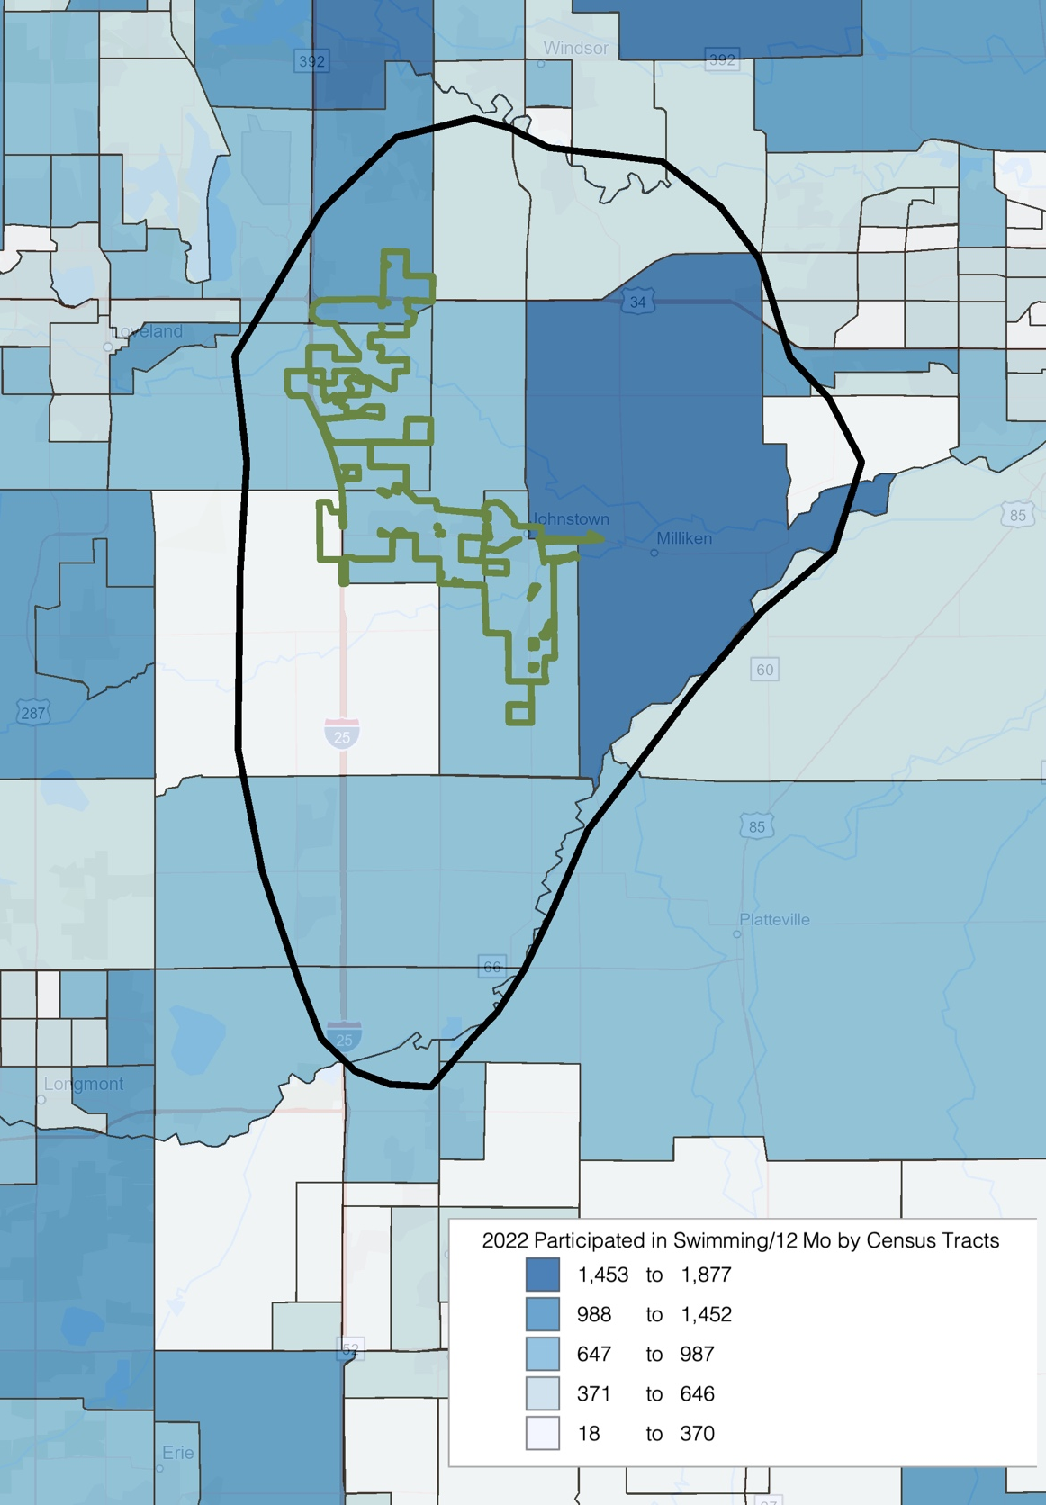

Anticipated Participation Number: Utilizing the average percentage from Table-A and B above plus the 2020 census information and census estimates for 2022 and 2027 (over age 7) the following comparisons are available.

Table C –Participation Growth or Decline for Indoor Activities in Primary Service Area

 | Average | 2020 Population | 2022 Population | 2027 Population | Difference
Swimming | 17.2% | 2,597 | 2,813 | 3,141 | 544
Did Not Participate | 20.5% | 3,094 | 3,351 | 3,742 | 648

Table D –Participation Growth or Decline for Indoor Activities in Secondary Service Area

 | Average | 2020 Population | 2022 Population | 2027 Population | Difference
Swimming | 17.2% | 7,253 | 8,448 | 9,288 | 2,036
Did Not Participate | 20.5% | 8,643 | 10,067 | 11,069 | 2,426

Note: These figures do not necessarily translate into attendance figures for various activities or programs. The “Did Not Participate” statistics refers to all 58 activities outlined in the NSGA 2021 Survey Instrument.

Table E – Participation Frequency Swimming

The NSGA classifies swimming based on how often individuals participate:

 | Frequent | Occasional | Infrequent
Swimming Frequency | 110+ | 25-109 | 6-24
Swimming Percentage of Population | 6.5% | 39.7% | 53.8%

In Table-E one can look at swimming and how it is defined with respect to visits being Frequent, Occasional, or Infrequent and then the percentage of population that participates.

Table F – Participation Numbers in Primary Service Area

 | Frequent | Occasional | Infrequent | Total
Swimming Frequency | 112 | 67 | 15
Population | 183 | 1,117 | 1,513
Visits | 20,476 | 74,815 | 22,698 | 117,989

Table-F takes the frequency information one step further and identifies the number of times individuals may participate in the activity, applies the percentage from Table-E to the 2020 swimming population (2,813) and then gives a total number of swimming days. This would indicate that a total of 117,989 swimming days are available within the Primary Service Area market. It is also important to note that those are being absorbed, on some level, by the other service providers in the area.

Table G – Participation Numbers in Secondary Service Area

 | Frequent | Occasional | Infrequent | Total
Swimming Frequency | 112 | 67 | 15
Population | 549 | 3,354 | 4,545
Visits | 61,498 | 224,696 | 68,172 | 354,366

Table-G takes the frequency information one step further and identifies the number of times individuals may participate in the activity, applies the percentage from Table-E to the 2020 swimming population (8,448) and then gives a total number of swimming days. This would indicate that a total of 354,366 swimming days are available within the Secondary Service Area market. It is also important to note that those are being absorbed, on some level, by the other service providers in the area.

The NSGA identifies participation in all activities that they track as frequent, occasional, and infrequent as illustrated in Table F & G. It is also important to further identify the uses of those categories.

Frequent Swimmers (6.5% of total swimming population) – These participants are largely the individuals participating in programs like club swimming. They can be described as competitive athletes of all variety to include multi-sport athletes. These participants are interested in traditional flat-water facilities, i.e., lap pools. Their preference is for deep water (greater than 6 feet) and cooler water temperatures (between 76-80).

Occasional Swimmers (39.7% of total swimming population) – These participants are the in between group of swimmers. The individuals on the high end of the uses per year are interested in swimming, or aquatic activities, as a means of exercise and prefer water like that of frequent swimmers. As you make your way to the mid-point and lower level of participation the reason for aquatic participation changes. Those individuals are either interested in aquatic participation for exercise/therapy or strictly the entertainment and social aspects of being in a pool. Those individuals on the mid and lower level of participation are interested in a different kind of water. They are more interested in a warmer water temperature (82-86 degrees) and shallow water (less than 4 feet up to a zero-depth entry).

Infrequent Swimmers (53.8% of total swimming population) – These participants are strictly interested in the social and entertainment aspects of swimming. They typically do not use participation in aquatic programs as a means of exercise, but rather socialization. The water that they are interested in is identical to the lower end of the occasional swimmers. However, they are also interested in a “wow-factor” which plays a key role in determining which facility they spend time at.

The NSGA also collects information based on purpose of participation. Within activities, participation is either categorized as “organized” or “unorganized.” Organized activities could include; swim lessons, dive lessons, swim team, water polo team, etc. Unorganized activities could include; water walking, lap swimming, open/free swim, etc. The percentages can be applied to the total number of swimmer days to determine market for organized and unorganized activities.

Primary Service Area | Percentage | Number of Swimmer Days
Organized | 10% | 11,799
Unorganized | 90% | 106,190

Secondary Service Area | Percentage | Number of Swimmer Days
Organized | 10% | 35,437
Unorganized | 90% | 318,929

Participation by Ethnicity and Race: The table below compares the overall rate of participation nationally with the rate for Hispanics and African Americans. Utilizing information provided by the National Sporting Goods Association's 2021 survey, the following comparisons are possible.

Table H – Comparison of National, African American and Hispanic Participation Rates in Primary Service Area

Indoor Activity | Primary Service Area | National Participation | African American Participation | Hispanic Participation
Swimming | 17.2% | 15.6% | 6.8% | 13.3%
Did Not Participate | 20.5% | 20.6% | 21.6% | 24.4%

There is a not significant Black population in the Primary Service Area. As such, these numbers may not play a factor with regards to overall participation. However, the Hispanic population (16%) should be considered.

Table I – Comparison of National, African American and Hispanic Participation Rates in Secondary Service Area

Indoor Activity | Secondary Service Area | National Participation | African American Participation | Hispanic Participation
Swimming | 17.2% | 15.6% | 6.8% | 13.3%
Did Not Participate | 20.5% | 20.6% | 21.6% | 24.4%

There is a not significant Black population in the Primary Service Area. As such, these numbers may not play a factor with regards to overall participation. However, the Hispanic population (17%) should be considered.

National Summary of Sports Participation: The following chart summarizes participation for indoor activities utilizing information from the 2021 National Sporting Goods Association survey.

Table J – Sports Participation Summary

Sport | Nat’l Rank | Nat’l Participation (in millions)
Exercise Walking | 1 | 125.0
Cardio Fitness | 2 | 86.1
Strength Training | 3 | 68.9
Exercising w/ Equipment | 4 | 57.2
Hiking | 5 | 48.8
Swimming | 6 | 47.2
Running/Jogging | 7 | 45.0
Bicycle Riding | 8 | 42.8
Weight Lifting | 9 | 37.5
Yoga | 10 | 30.7
Fishing (fresh water) | 11 | 29.5
Workout @ Club | 13 | 24.6
Basketball | 14 | 22.5
Golf | 16 | 19.0
Target Shooting (live ammunition) | 17 | 18.8
Hunting w/ Firearms | 18 | 16.4
Boating (motor/power) | 19 | 14.6
Soccer | 20 | 14.5
Tennis | 22 | 13.8
Kayaking | 24 | 11.5
Baseball | 26 | 11.3
Volleyball | 27 | 10.8
Fishing (salt water) | 29 | 9.6
Softball | 30 | 9.3
Football (touch) | 32 | 8.2
Canoeing | 33 | 7.8
Hunting w/ Bow & Arrow | 34 | 6.9
Football (tackle) | 35 | 6.7
Mountain Biking (off road) | 38 | 6.0
Football (flag) | 41 | 5.4
Water Skiing | 49 | 3.8
Pickleball | 50 | 3.6

Nat’l Rank: Popularity of sport based on national survey.

Nat’l Participation: Population that participate in this sport on national survey.
National Participation by Age Group: Within the NSGA survey, participation is broken down by age groups. As such B*K can identify the top 3 age groups participating in the activities reflected in this report.

Chart K – Participation by Age Group:

Activity | Largest | Second Largest | Third Largest
Aerobics | 35-44 | 25-34 | 45-54
Baseball | 7-11 | 12-17 | 25-34
Basketball | 12-17 | 25-34 | 18-24
Bicycle Riding | 55-64 | 45-54 | 12-17
Billiards/Pool | 25-34 | 34-44 | 45-54
Bowling | 25-34 | 35-44 | 18-24
Cheerleading | 12-17 | 7-11 | 18-24
Exercise Walking | 55-64 | 65-74 | 45-54
Exercise w/ Equipment | 25-34 | 45-54 | 55-64
Football (flag) | 7-11 | 12-17 | 25-34
Football (tackle) | 12-17 | 18-24 | 7-11
Football (touch) | 12-17 | 25-34 | 7-11
Gymnastics | 7-11 | 12-17 | 25-34
Lacrosse | 12-17 | 7-11 | 18-24
Martial Arts MMA | 7-11 | 25-34 | 12-17
Pickleball | 12-17 | 65-74 | 18-24
Pilates | 25-34 | 35-44 | 45-54
Running/Jogging | 25-34 | 35-44 | 45-54
Skateboarding | 12-17 | 18-24 | 7-11
Soccer | 7-11 | 12-17 | 25-34
Softball | 12-17 | 7-11 | 25-34
Swimming | 55-64 | 12-17 | 7-11
Tables Tennis | 25-34 | 18-24 | 12-17
Tennis | 25-34 | 35-44 | 12-17
Volleyball | 12-17 | 25-34 | 18-24
Weight Lifting | 25-34 | 45-54 | 35-44
Workout at Clubs | 25-34 | 35-44 | 45-54
Wrestling | 12-17 | 25-34 | 7-11
Yoga | 25-34 | 35-44 | 45-54
Did Not Participate | 45-54 | 55-64 | 65-74

Largest: Age group with the highest rate of participation.
Second Largest: Age group with the second highest rate of participation.
Third Largest: Age group with the third highest rate of participation.

National Sports Participation Trends: Below are listed several sports activities and the percentage of growth or decline that each has experienced nationally over the last ten years (2012-2021).

Table L – National Activity Trend (in millions)

 | 2012 Participation | 2021 Participation | Percent Change
Kayaking | 7.2 | 11.5 | +59.7%
Hunting w/ Bow & Arrow | 5.1 | 6.9 | +35.3%
Yoga | 22.9 | 30.7 | +34.1%
Skateboarding | 5.4 | 6.7 | +24.1%
Exercise Walking | 102.1 | 125 | +22.4%
Weight Lifting | 31.1 | 37.5 | +20.6%
Hiking | 42.2 | 48.8 | +15.6%
Running/Jogging | 40 | 45 | +12.5%
Wrestling | 2.8 | 3.1 | +10.7%
Mountain Biking (off road) | 5.5 | 6 | +9.1%
Bicycle Riding | 39.3 | 42.8 | +8.9%
Backpack/Wilderness Camping | 11.7 | 12.4 | +6.0%
Soccer | 13.7 | 14.5 | +5.8%
Water Skiing | 3.6 | 3.8 | +5.6%
Volleyball | 10.3 | 10.8 | +4.9%
Target Shooting (airgun) | 4.9 | 5.1 | +4.1%
Tennis | 13.6 | 13.8 | 1.5%
Exercising w/ Equipment | 57.7 | 57.2 | -0.9%
Swimming | 48.6 | 47.1 | -3.1%
Fishing (fresh water) | 30.8 | 29.5 | -4.2%
Baseball | 12.1 | 11.3 | -6.6%
Golf | 21.1 | 19 | -10.0%
Fishing (salt water) | 10.7 | 9.6 | -10.3%
Softball | 10.5 | 9.3 | -11.4%
Football (touch) | 9.3 | 8.2 | -11.8%
Basketball | 25.6 | 22.5 | -12.1%
Target Shooting (live ammunition) | 21.7 | 18.8 | -13.4%
Boating (motor/power) | 17 | 14.6 | -14.1%
Football (tackle) | 7.9 | 6.7 | -15.2%
Hunting w/ Firearms | 19.4 | 16.4 | -15.5%
Football (flag) | 6.7 | 5.4 | -19.4%
Workout @ Club | 35.2 | 24.6 | -30.1%

2012 Participation: The number of participants per year in the activity (in millions) in the United States.
2021 Participation: The number of participants per year in the activity (in millions) in the United States.
Percent Change: The percent change in the level of participation from 2012 to 2021.

Section III –Participation, Trends & Providers

Aquatic Participation Trends: Swimming is one of the most popular sports and leisure activities, meaning that there is a significant market for aquatic pursuits. Approximately 17.6% of the population in the Mountain region of the country participates in aquatic activities. This is a significant segment of the population.

Despite the recent emphasis on recreational swimming the more traditional aspects of aquatics (including swim teams, instruction and aqua fitness) remain as an important part of most aquatic centers. The life safety issues associated with teaching children how to swim is a critical concern in most communities and competitive swim team programs through USA Swimming, high schools, masters, and other community based organizations continue to be important. Aqua fitness, from aqua exercise to lap swimming, has enjoyed strong growth during the last ten years with the realization of the benefits of water-based exercise.

A competitive pool allows for a variety of aquatic activities to take place simultaneously and can handle aqua exercise classes, learn to swim programs as well competitive swim training and meets (short course and possibly long course). In communities where there are several competitive swim programs, utilizing a pool with 8 lanes or more is usually important. A competitive pool that is designed for hosting meets will allow a community to build a more regional or even national identity as a site for competitive swimming. However, it should be realized that regional and national swim meets are difficult to obtain on a regular basis, take a considerable amount of time, effort and money to run; can be disruptive to the regular user groups and can be financial losers for the facility itself. On the other side, such events can provide a strong economic stimulus to the overall community.

Competitive diving is an activity that is often found in connection with competitive swimming. Most high school and regional diving competition centers on the 1-meter board with some 3 meter events (non-high school). The competitive diving market, unlike swimming, is usually very small (usually 10% to 20% the size of the competitive swim market) and has been decreasing steadily over the last ten years or more. Thus, many states have or are considering the elimination of diving as a part of high school swimming. Diving programs have been more viable in markets with larger populations and where there are coaches with strong diving reputations. Moving from springboard diving to platform (5 meter and 10 meter, and sometimes 3 and 7.5 meters), the market for divers drops even more while the cost of construction with deeper pool depths and higher dive towers becomes significantly larger. Platform diving is usually only a competitive event in regional and national diving competitions. As a result, the need for inclusion of diving platforms in a competitive aquatic facility needs to be carefully studied to determine the true economic feasibility of such an amenity.

There are a couple of other aquatic sports that are often competing for pool time at competitive aquatic centers nationwide. However, their competition base and number of participants is often smaller and face barriers of entry fighting for pool time including a more organized competitive swimming community and existing agreements for pool space at facilities with pools large enough and deep enough to host them. Water polo is a sport that continues to be extremely popular in the west, particularly in Colorado and whose numbers and participation rates are in many school districts are higher than those of swimming in high school athletics. Water polo uses a space of 25 yards or meters by 45-66 feet wide (the basic size of an 8 lane, 25-yard pool). However, a minimum depth of 6 foot 6 inches is required which is often difficult to find in more community based facilities. Floating cage water polo has become the standard in many regions and requires an even larger pool as the floating cages take up additional pool space. Artistic swimming also utilizes aquatic facilities for their sport and they also require deeper water of 7-8 feet. This also makes the use of some community pools difficult. As a result of the need for more deep water for aquatic sports many modern community aquatic centers are building multiple pools.

Without doubt the hottest trend in aquatics is the leisure pool concept. This idea of incorporating slides, lazy rivers (or current channels), fountains, zero depth entry and other water features into a pool’s design has proved to be extremely popular for the recreational user. The age of the conventional pool in most recreational settings has greatly diminished. Leisure pools appeal to the younger kids (who are the largest segment of the population that swims) and to families. These types of facilities are able to attract and draw larger crowds and people tend to come from a further distance and stay longer to utilize such pools. This all translates into the potential to sell more admissions and increase revenues. It is estimated conservatively that a leisure pool can generate up to 30% more revenue than a comparable conventional pool and the cost of operation while being higher, has been offset through increased revenues. Of note is the fact that patrons seem willing to pay a higher user fee with this type of pool that is in a park like setting than a conventional aquatics facility.

Another trend that is growing more popular in the aquatic’s field is the development of a raised temperature therapy pool for relaxation, socialization, and rehabilitation. This has been effective in bringing in swimmers who are looking for a different experience and non-swimmers who want the advantages of warm water in a different setting. The development of natural landscapes has enhanced this type of amenity and created a pleasant atmosphere for adult socialization.

The multi-function indoor aquatic center concept of delivering aquatics services continues to grow in acceptance with the idea of providing for a variety of aquatics activities and programs in an open design setting that features a lot of natural light, interactive play features and access to an outdoor sun deck. The placing of traditional instructional/competitive pools, with shallow depth/interactive leisure pools and therapy water, in the same facility has been well received in the market. This idea has proven to be financially successful by centralizing pool operations for recreation service providers and through increased generation of revenues from patrons willing to pay for an aquatics experience that is new and exciting. Indoor aquatic centers have been instrumental in developing a true family appeal for community-based facilities. The keys to success for this type of center revolve around the concept of intergenerational use in a quality facility that has an exciting and vibrant feel in an outdoor like atmosphere.

Also changing is the orientation of aquatic centers from stand-alone facilities that only have aquatic features to more of a full-service recreation center that has fitness, sports and community based amenities. This change has allowed for a better rate of cost recovery and stronger rates of use of the aquatic portion of the facility as well as the other “dry side” amenities.

Aquatic Facilities Market Orientation: Based on the market information, the existing pools, and typical aquatic needs within a community, there are specific market areas that need to be addressed with any aquatic facility. These include:

- Leisure/recreation aquatic activities - This includes a variety of activities found at leisure pools with zero depth entry, warm water, play apparatus, slides, seating areas and deck space. These are often combined with other non-aquatic areas such as concessions and birthday party or other group event areas.

- Instructional programming – The primary emphasis is on teaching swimming and lifesaving skills to many different age groups. These activities have traditionally taken place in more conventional pool configurations but should not be confined to just these spaces. Reasonably warm water, shallow depth with deeper water (4 ft. or more), and open expanses of water are necessary for instructional activities. Easy pool access, a viewing area for parents, and deck space for instructors is also crucial.

- Fitness programming – These types of activities continue to grow in popularity among a large segment of the population. From aqua exercise classes, to lap swimming times, these programs take place in more traditional settings that have lap lanes and large open expanses of water available at a 3 1/2 to 5 ft. depth.

- Therapy – A growing market segment for many aquatic centers is the use of warm, shallow water for therapy and rehabilitation purposes. Many of these services are offered by medically based organizations that partner with the center for this purpose.

- Social/relaxation - The appeal of using an aquatics area for relaxation has become a primary focus of many aquatic facilities. This concept has been very effective in drawing non-swimmers to aquatic facilities and expanding the market beyond the traditional swimming boundaries. The use of natural landscapes and creative pool designs that integrate the social elements with swimming activities has been most effective in reaching this market segment.

- Special events/rentals - There is a market for special events including kid’s birthday parties, corporate events, community organization functions, and general rentals to outside groups. The development of this market will aid in the generation of additional revenues and these events/rentals can often be planned for after or before regular hours or during slow use times. It is important that special events or rentals not adversely affect daily operations or overall center use.

Specific market segments include:

- Families – Within this market, an orientation towards family activities is essential. The ability to have family members of different ages participate in a fun and vibrant facility is essential.

- Pre-school children – The needs of pre-school age children need to be met with very shallow or zero depth water which is warm and has play apparatus designed for their use. Interactive programming involving parents and toddlers can also be conducted in more traditional aquatic areas as well.

- School age youth – A major focus of most pools is to meet the needs of this age group from recreational swimming to competitive aquatics. The leisure components such as slides, fountains, lazy rivers and zero depth will help to bring these individuals to the pool on a regular basis for drop-in recreational swimming. The lap lanes provide the opportunity and space necessary for instructional programs and aquatic team use.

- Teens – Another aspect of many pools is meeting the needs of the teenage population. Serving the needs of this age group will require leisure pool amenities that will keep their interest (slides) as well as the designation of certain “teen” times of use.

- Adults – This age group has a variety of needs from aquatic exercise classes to lap swimming, triathlon training and competitive swimming through the master’s program.

- Seniors – As the population of the United States and the service area continues to age, meeting the needs of an older senior population will be essential. A more active and physically oriented senior is now demanding services to ensure their continued health. Aqua exercise, lap swimming, therapeutic conditioning and even learn to swim classes have proven to be popular with this age group.

- Special needs population – This is a secondary market, but with the A.D.A. requirements and the existence of shallow warm water and other components, the amenities are present to develop programs for this population segment. Association with a hospital and other therapeutic and social service agencies will be necessary to reach this market.

- Special interest groups – These include swim teams (and other aquatic teams), school district teams, day care centers and social service organizations. While the needs of these groups can be great, their demands on an aquatics center can often be incompatible with the overall mission of the facility. Care must be taken to ensure that special interest groups are not allowed to dictate use patterns for the center.

With the proper pools and strong utilization of the aquatics area, it is possible to meet most of the varied market orientations as outlined above.

From the 2010-2020 Census, the Primary Service Area experienced a 5.18% increase in population.
From the 2010-2020 Census, the Secondary Service Area experienced a 5.88% increase in population.
Consumer Spending data are derived from the 2018 and 2019 Consumer Expenditure Surveys, Bureau of Labor Statistics. ESRI forecasts for 2022 and 2027.
Consumer Spending data are derived from the 2018 and 2019 Consumer Expenditure Surveys, Bureau of Labor Statistics.
This rank is based upon the 58 activities reported on by NSGA in their 2021 survey instrument.

